1. XAMPP is needed to run the code from localhost

XAMPP is a free and open-source cross-platform web server solution stack package developed by Apache.

2. User needs to start Apache and MySQL to start the localhost

3. User need to create a sql database to work the web pages as it is designed to use only after logging in.

So first create a database in myPhpAdmin

Give database name to “info” as I used this name , else you have to change the db name in many where on the codes.

4. create a new table with 6 rows

5. structure

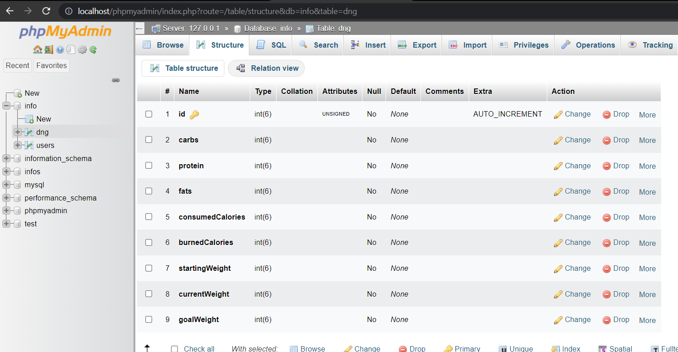

You also can structure the table using the steps below.

To create a database in XAMPP phpMyAdmin and generate the **users** table with the specified columns, follow these steps:

1. Start XAMPP and make sure that the Apache and MySQL services are running.
2. Open your web browser and navigate to <http://localhost/phpmyadmin/>.
3. Click on the "Databases" tab in the top menu.
4. Enter a name for your database in the "Create database" field and click on the "Create" button.
5. Once the database is created, click on its name in the left-hand column to select it.
6. Click on the "SQL" tab in the top menu to open the SQL editor.
7. In the editor, enter the following SQL query to create the **users** table:

CREATE TABLE users (

id INT(11) UNSIGNED AUTO_INCREMENT PRIMARY KEY,

name VARCHAR(50) NOT NULL,

username VARCHAR(30) NOT NULL UNIQUE,

email VARCHAR(100) NOT NULL UNIQUE,

password VARCHAR(255) NOT NULL,

profile_picture VARCHAR(255)

);

1. Click on the "Go" button to execute the query and create the table.
2. You can now use the **INSERT** query you provided to add data to the **users** table.

••••

CREATE TABLE dng (

id INT(6) UNSIGNED AUTO_INCREMENT PRIMARY KEY,

carbs INT(6) NOT NULL,

protein INT(6) NOT NULL,

fats INT(6) NOT NULL,

consumedCalories INT(6) NOT NULL,

burnedCalories INT(6) NOT NULL,

startingWeight INT(6) NOT NULL,

currentWeight INT(6) NOT NULL,

goalWeight INT(6) NOT NULL,

created_at TIMESTAMP DEFAULT CURRENT_TIMESTAMP

);

6. you can also use the file to import it your database.



(copy it and paste in desktop to retrieve it)

1. Move the files into this path:   
     
   C:\xampp\htdocs

In my case my file was on

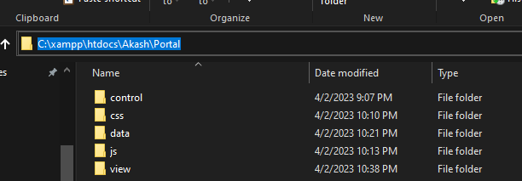

1. Initiate in browser   
   Graphical user interface, text, application, chat or text message

   Description automatically generated

it takes to log in page because log in must require.

1. Create an account first and then log in using username password and explore the site.   
     
   Thank you!!!

<https://github.com/akashasmaul/Student-Portal-Web-Development-Project>